15A bank facilitates for transactions (for its customers) through its Atm’s.  Prior to, as well as ongoing, establishing an account with a customer the bank ensures they perform suitability checks to ensure they want to do business with a customer.

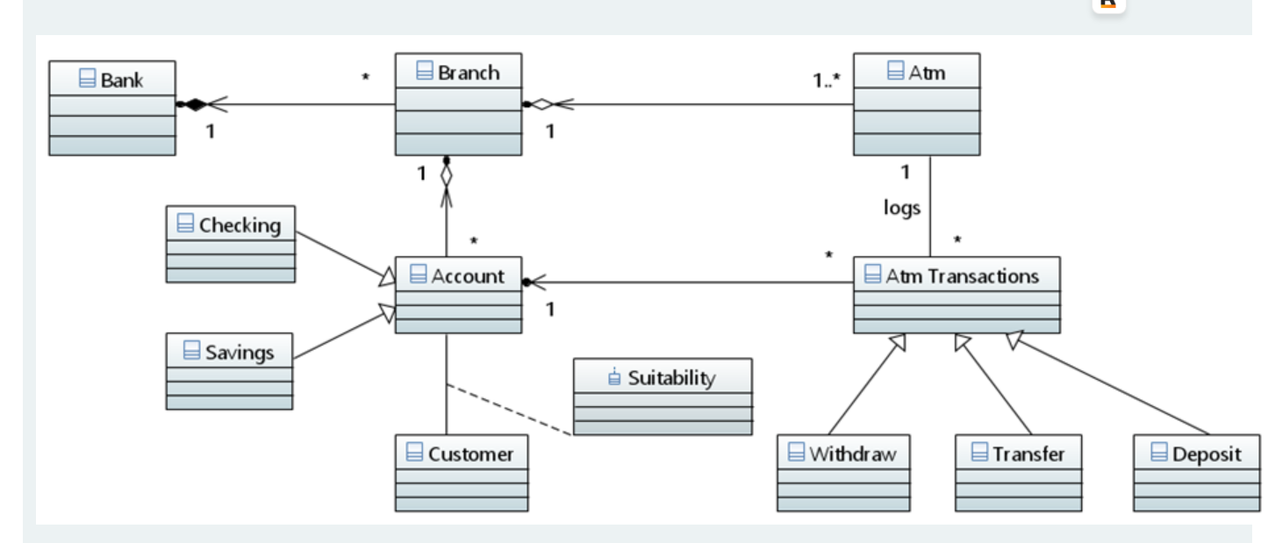

Based on the above diagram, in the following, choose all statements which are true.

a.

A branch can have no more than one Atm.

Destroying the Branch class will destroy the Atm class.



c.

The relationship between Atm and Atm Transactions implies that Atm can potentially use logs to access attributes/operations of Atm Transactions.



d.

The Suitability class does not own the attributes of the Account or Customer class.



e.

Destroying the bank would destroy the branches of the bank.



f.

An Atm Transaction can only facilitate transactions for a single account.



g.

The operations within Withdraw, Transfer and Deposit are all the same since the classes are subtypes of Atm Transactions.

14 Select the correct statements about software engineering.



a.

It provides a framework within which the activities of software development can be repeated on other similar applications.



b.

Increased use of cloud-technology guarantees the reduction in software complexity.



c.

Most software development projects are completed on time and within budget irrespective of the type of approach to development.



d.

The importance of understanding the software specification and user requirements depends on the type of software development approach used.



e.

It guarantees that standalone systems have the same level of heterogeneity as web-based applications.



f.

In addition to technical requirements, it necessitates developers to think of (and incorporate where necessary) ethical issues including the legal/regulatory environment in which an application will operate.



g.

It is primarily concerned with those aspects of software development which can be automated.

13.Choose all statements which are true regarding UML.



a.

UML can model any type of software application irrespective of the type of architecture.



b.

Analysis of UML models can reveal problems with user requirements leading to early detected and aiding in the revision of such requirements.



c.

Using UML provides an alternative to traditional software development life cycle (SDLC) processes and is now viewed as the standard SDLC.



d.

UML is too high-level in order for code to be automatically generated from its models.



e.

There is no connection between the different types of UML models as they all provide a particular view of user requirements which cannot be reconciled.



f.

The UML method is firmly grounded in sound mathematical theory.

12.Your company (a manufacturing firm) is undertaking a software systems development.  The system is to support an order management tool to help the company better manage its inventory, purchases and receivables.  The system should provide automated notifications when payments from customers have not been received within two weeks of the deadline date and should alert the Finance department when payments by the company to suppliers are within one week of its deadline.  The system should also provide a unique id for each item of inventory irrespective of its type.  Formal mathematical methods will be used in the development of the system.

In the following, choose all statements which are true regarding the application of software quality techniques to the system development.



a.

The Beta testing will involve users and developers in both designing and applying tests to verify the system.



b.

Tests should include cases where the deadline for the company to receive payments is less than two weeks as well as those where the deadline to make payments is greater than one week.



c.

Tests should include cases where the same id is used for two different inventory items.



d.

Release testing will be facilitated by use of analysing the structure of the systems code.



e.

The formal method can be used to validate user requirements.

11.Choose all statements which are true in relation to software development life-cycles.



a.

Iterative approaches typically iterate each stage of the software development lifecycle an equal number of times.



b.

Incremental approaches are restricted to delivering an equal amount of functionality in each software increment produced.



c.

Iterative development typically plans across several potential future increments.



d.

The costs of incremental development are relatively harder to estimate than sequential approaches.



e.

Iterative developments are less accommodating to variations in user requirements.

10 You are tasked with the responsibility of writing a tool for generating Java code from UML.  The class diagram provides partial information on the attributes of a trading position.  Missing from the diagram are the operations.  A state diagram is also shown of some possible states for the trading position.  The state diagram shows that a position is held if its price is initially less than a certain value or is made available to sell or buy otherwise.  Once available to buy/sell the position can be increased or decreased.  State transitions can terminate by way of a market crash.

The following outline code has been generated from the tool:

In the following, choose all statements which are true.

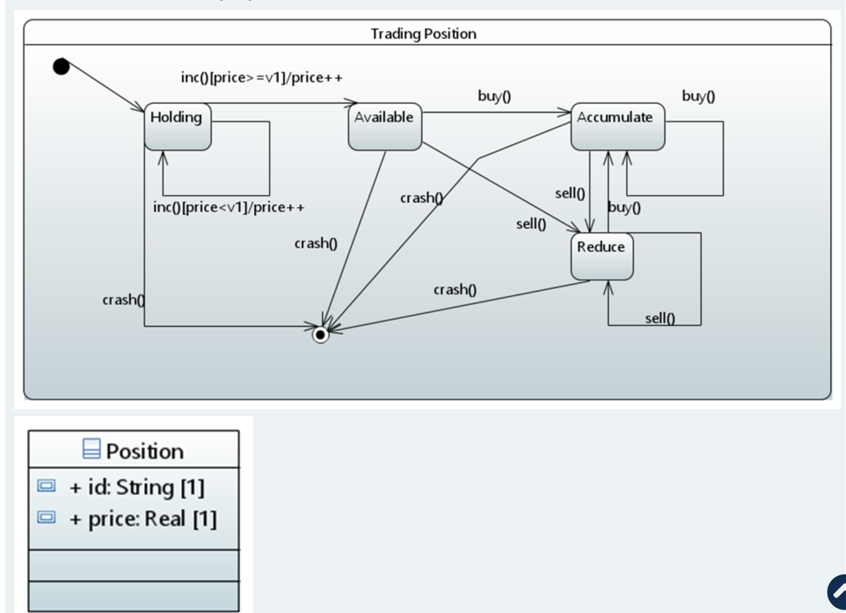



a.

S1==Available, S2==State (where State is an abstract class), S3==Accumulate, S4==Reduce.



b.

S1==Reduce, S2==Holding, S3==Available.



c.

Operations of the Position class should include crash, inc, buy and sell.



d.

Operations of the Position class should include inc, available, accumulate, reduce, and crash.



e.

Y==Available.



f.

Y==Position.



g.

Since the state machine contains loops, the number of states is infinite.



h.

The Position class should have operations ret_op1 which returns the amount invested in a position and setop1 which increases the investment by a specified amount.

9 Delroy is responsible for developing and maintaining the remuneration rewards system for the Sales team at his organisation.  The organisation wants to make their IT system more efficient and has decided to try and link the HR system with that of the remuneration system.  At present, the HR system stores employee details as a string array (i.e., an array whose items are strings containing employee details) and the remuneration as a list of an employee object (each object providing details of an employee).

Based on the above scenario, choose one or more of the following which is more appropriate for Delroy.



a.

Delroy should suggest manual workarounds as the requirement is non-functional.



b.

Delroy should rewrite the remuneration system so that it conforms to the organisational HR system in terms of how it stores employee details.



c.

Delroy should use the Iterator design pattern as this allows manipulating data structures without knowing the precise representation.



d.

Delroy should use the Adapter design pattern as this will allow for collaboration between the two systems.



e.

Delroy should use the Chain of Responsibility design pattern as this would allow the code to determine which type of data structure to use.